Creamy Corn Pasta With Basil

By Melissa Clark
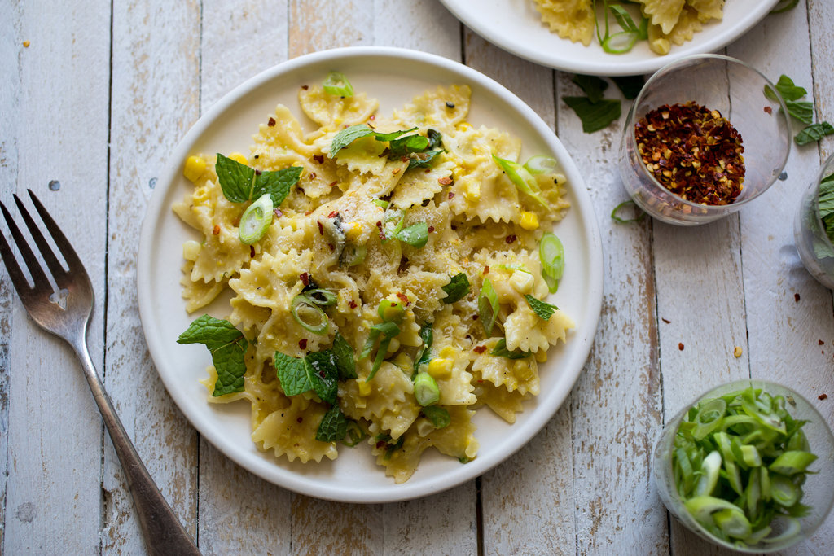
Watch
Andrew Scrivani for The New York Times
Total Time
30 minutes
Rating
5(9,860)
Comments
Read 1,000 comments
There’s no cream in this wonderfully summery pasta dish, just a luscious sauce made from puréed fresh corn and sweet sautéed scallions, along with Parmesan for depth and red chile flakes for a contrasting bite. Be sure to add the lemon juice and fresh herbs at the end; the rich pasta really benefits from their bright, fresh flavors. And while this is best made at the height of corn season, it’s still quite good even with out-of-season supermarket ears, or with frozen corn.
